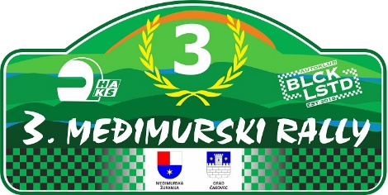

START NUMBER

E N T R Y F O R M

ENTRY REGISTRATION FOR (mark with X) | GEN |  | CEZ  HIST. |  | MZPH |  | PH |  | OPZ

CEZ Historic rally championship, MZPH – International Zone Croatian Championship, PH – Croatian Championship, OPZ – Open Zagreb Championship

 | COMPETITOR | FIRST DRIVER | CO-DRIVER
Team name
Family name
First name
Date of birth
Nationality (as licence)
Postal address
Passport number
Address for correspondence
Telephone
Mobile
Fax
E mail
Competitions licence No.
Issuing ASN
Driving licence No.

DETAILS OF CAR
Make |  | Country of registration
Model |  | Registration No.
Year of manufacture |  | C.C.
Klasa (GEN, CEZ HISTORIC MZPH, PH, PH HISTORIC AARC, OPZ KPA) |  | Engine No
Homologation No. |  | Tech. Passport No.

Organiser’s proposed advertising accepted (choose): | YES | NO
Junior (choose): | YES | NO

ENTRY FEE
(for this entry form to be valid it must be accompanied by the appropriate entry fees, a receipt for the full amount paid to the entrants ASN, a bankers draft or details of a bank transfer etc.)

International rally & FIA CEZ |  | 400,00 € - up to April 24th 2024 (24:00)
MZPH & PH | Class 4 & Junior | Class 2 & 3 | Class GEN & Class 1
up to April 24th 2024 (24:00) | 200,00 € | 300,00 € | 400,00 €

SEEDING INFORMATION
Driver:

Priority: YES / NO If yes, choose: FIA A / FIA B / National National Championship winner: YES / NO

Year |  | Event | Car | Group | O/A Position | Class Position | No. of Finishers
Championship

DECLARATION OF INDENITY
The entrant, driver and co-driver jointly and severally acknowledge and agree the following:
- To abide by and be bound by the codes and regulations of the 3rd MEĐIMURSKI RALLY 2024, held under the International Sporting Code, the Sporting and Technical Regulations of the FIA, the Regulations of the relevant National Sporting Authority (ASN) and the Supplementary Regulations issued for the 3rd MEĐIMURSKI RALLY 2024.
- That motor sport is dangerous and accidents causing death, bodily damage, disability and property damage can and do happen and in consideration of the acceptance of this entry, we agree that neither the FIA, the relevant ASN, the organisers and/or promoters and their respective officers, servants, representatives and agents and any other parties shall be under any liability for our death, or any bodily injury, loss or damage which may be sustained or incurred by us as a result of participation in the 3rd MEĐIMURSKI RALLY, and to the fullest permitted by law agree to indemnity and hold harmless each of those parties.

ACKNOWLEDGEMENT AND AGREEMENT

With my signature, I guarantee that all the information provided on the Entry Form is correct and I fully acknowledge and accept the above-mentioned indemnification conditions, as well as the conditions related to my participation in this competition. By signing the Entry Form for the performance, the Applicant gives express consent to AK "Delta" Zagreb, as a voluntary, special, informed and unequivocal consent for the use and processing of personal data relating to the Applicant, the processing of which is necessary for undertaking regular work in the organization of the event - up to revokes.

ASN Stamp* | Signature of Competitor | Signature od First Driver | Signature of Co-driver

* Or letter from the entrant’s ASN authorising and approving the entry

E-mail for entries: medjimurskirally@akdelta.hr
Date:

