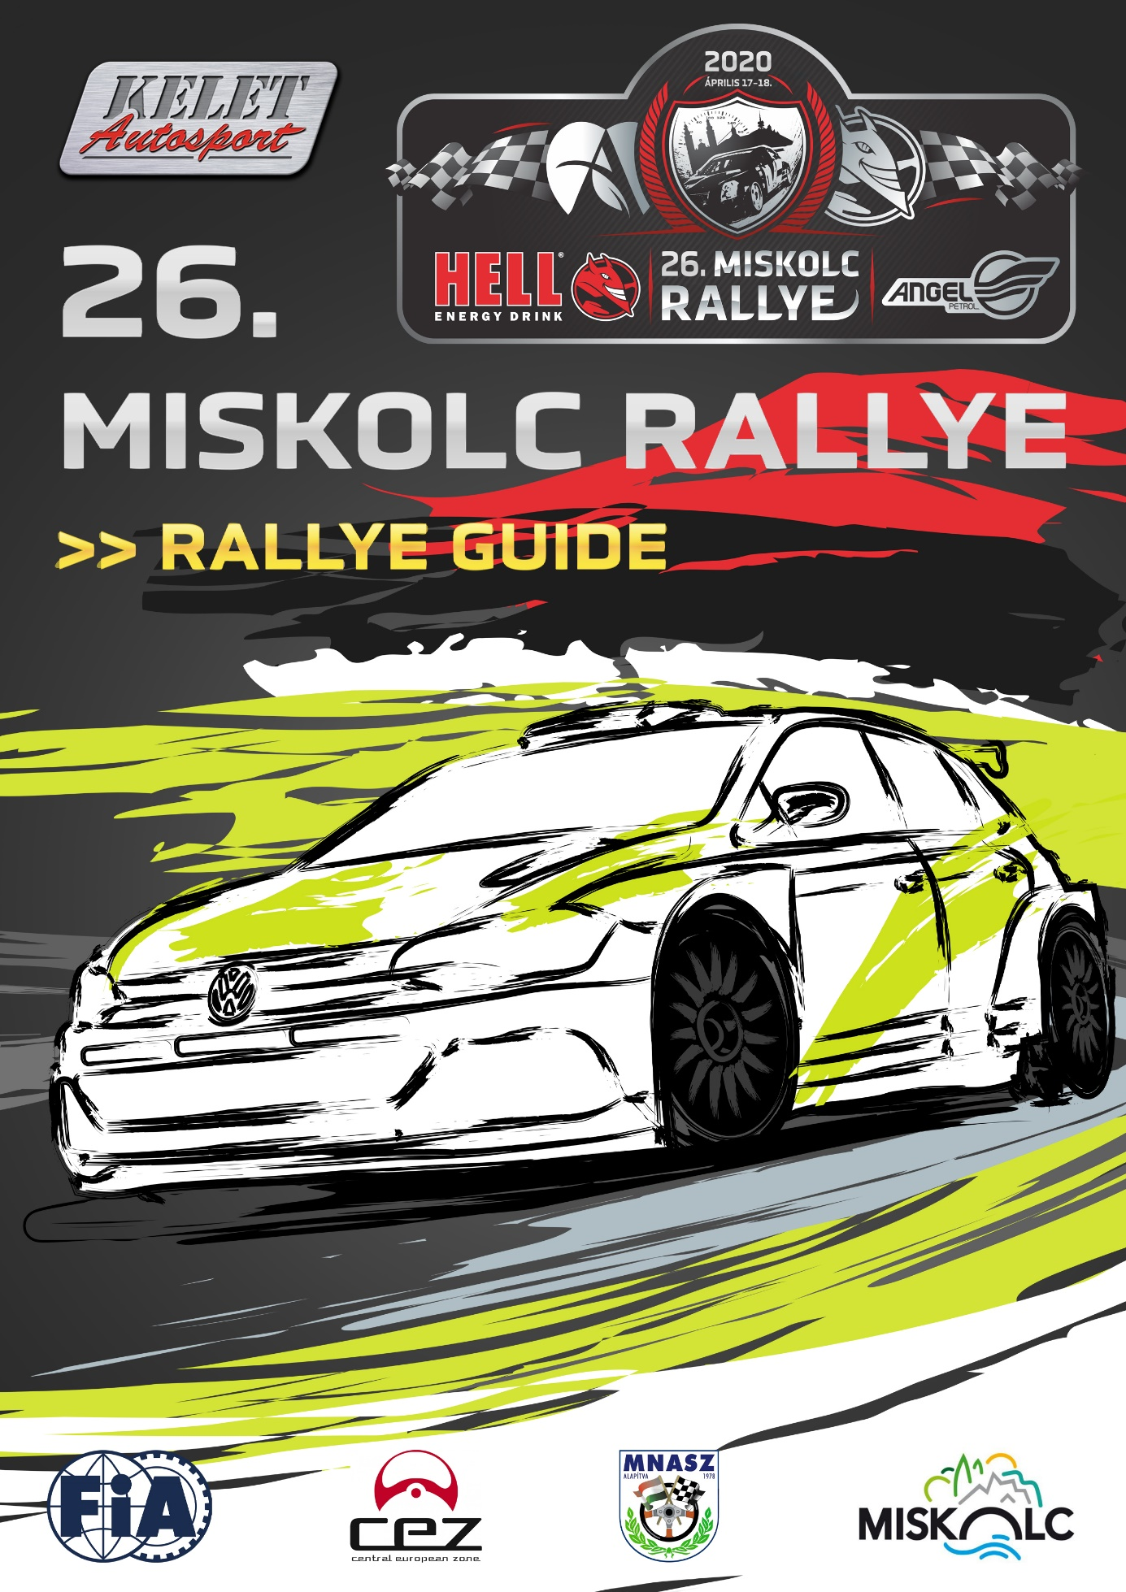

TABLE OF CONTENT

BASIC INFORMATION 3

CONTACT DETAILS 3

HEADQUARTER AND PRESS OFFICE 3

ENTRY DETAILS 5

SERVICE PARK 6

RECONNAISSANCE 6

SCRUTINEERING 6

QUALIFICATION 7

START PROCEDURE 7

FINISH PROCEDUE 7

OFFICIAL TEST 8

APPENDIX/ITINERARY AND MAPS 9

- BASIC INFORMATION

The Miskolc Rallye 2020 will be run in compliance with the International Sporting Code and its appendixes, the 2020 FIA Regional Rally Sporting Regulations and the National Rally Sporting Regulations which comply with the FIA regulations – National Championship Regulations 2020, National Sporting Regulations and the Supplementary Regulation.

Surface of SS 100,00% asphalt, CEZ, Rally1, Rally1-ORC, HIST, Rally2,

CEZ, Rally1, Rally1- ORC HIST Rally2

Total lenght of rally: 403,45km (38,29%) 360,15km (35,15%) 269,50km (38,21%)

Number of special stages: 12 10 8

Total length of special stages: 154,47 km 128,72 km 102,98 km

Number of sections: 3 3 2

Number of legs: 1 1 1

CONTACT DETAILS

E-mail | keletautosport@gmail.com
Website | www.miskolcrally.hu
Facebook | https://m.facebook.com/rally.miskolc/
Instagram | https://instagram.com/miskolcrally/
Clerc of the Course | Miklos Lovay
Organizer | Kelet-Autósport Kft.
CRO: | Jana Riečičiarová, Janos Bernhardt,  Krisztian Holecz

HEADQUARTER AND PRESS OFFICE

DVTK Stadium
HU-3533, Miskolc, Andrássy Gyula street 61.

Headquarter and Press Office opening hours:
- 2020.04.16. 08:00 – 21:00
- 2020.04.17. 07:00 – 21:00
- 2020.04.18. 07:00 – 20:00

2020.04.15. WEDNESDAY
09:00 – 16:00 | DISTRIBUTION OF ROAD BOOK (all competitors) | Avalon, HU-3519, Miskolc-Tapolca, Iglói street 15. (Karting track)
09:00 – 18:00 | RESONNAISSANCE (all competitors) | AS PER ROAD BOOK
2020.04.16. THURSDAY
08:00 – 10:00 | DISTRIBUTION OF ROAD BOOK | HEADQUARTER
08:00 – 13:00 | ADMISNISTRATIVE CHECK (CEZ, RALLY1, RALLY1-ORC, HIST) | HEADQUARTER
13:30-19:00 | SCRUTINEERING (CEZ, RALLY1, RALLY1-ORC, HIST) | DVTK STADIUM
08:00 – 20:00 | RECONNAISSANCE | WEDNESDAY-THURSDAY-FRIDAY
08:00 | SERVICE PARK OPENING | DVTK STADIUM
2020.04.17. FRIDAY
07:00 – 11:00 | DISTRIBUTION OF ROAD BOOK (RALLYE2) | HEADQUARTER
07:00 – 11:00 | ADMISNISTRATIVE CHECK (RALLY2) | HEADQUARTER
07:30 – 11:30 | SCRUTINEERING (RALLY2) | DVTK STADIUM
09:30 – 12:00 | QUALIFICATION | FELSŐNYÁRÁD-SAJÓKAZA
14:00- 14:30 | SELECTION OF STARTING POSITION | HEADQUARTER
14:30 | MANDATORY DRIVERS AND TEAM MANAGERS BRIEFING | HEADQUARTER
14:00 | PROVISIONAL RACE AND PROLOGUE START LIST PUBLICATION (Rally2) | HEADQUARTER, ONLINE NOTICE BOARD
16:00 | PROVISIONAL RACE AND PROLOGUE START LIST PUBLICATION (CEZ, HIST, RALLY1, RALLY1-ORC) | HEADQUARTER, ONLINE NOTICE BOARD
14:30 | RACE AND PROLOGUE START LIST PUBLICATION (Rally2) | HEADQUARTER, ONLINE NOTICE BOARD
16:30 | RACE AND PROLOGUE START LIST PUBLICATION (CEZ, HIST, RALLY1, RALLY1-ORC) | HEADQUARTER, ONLINE NOTICE BOARD
15:45 | START OF THE RACE (LEG 0) RALLY2 | DVTK STADIUM
17:45 | START OF THE RACE (LEG 0) HIST | DVTK STADIUM
18:15 | START OF THE RACE (LEG 0) CEZ, RALLY1, RALLY1-ORC | DVTK STADIUM
16:20 | PROLOGUE START (RALLY2) | SALAKPÁLYA ITINER SZERINT
18:20 | PROLOGUE START (HIST) | SALAKPÁLYA ITINER SZERINT
18:50 | PROLOGUE START (CEZ, RALLY1, RALLY1-ORC) | SALAKPÁLYA ITINER SZERINT
22:00 | 1.LEG START LIST PUBLICATION | HEADQUARTER, ONLINE NOTICE BOARD
2020.04.18. SATURDAY
06:30 | START OF 1.LEG (CEZ, RALLY1, RALLY1-ORC) | DVTK STADIUM
08:15 | START OF 1.LEG (HIST) | DVTK STADIUM
09:00 | START OF 1.LEG (RALLY2) | DVTK STADIUM
17:04 | FINISH OF THE RACE, FINISH/PRICE GIVING CEREMONY (RALLY2) | DVTK STADIUM
18:28 | FINISH OF THE RACE, FINISH/PRICE GIVING CEREMONY (CEZ, RALLY1, RALLY1-ORC) | DVTK STADIUM
19:55 | FINISH OF THE RACE, FINISH/PRICE GIVING CEREMONY (HIST) | DVTK STADIUM
RIGHT AFTER FINISH OF THE RACE | FINAL SCRUTINEERING | AUTÓSZERVIZ, HU-3533, Miskolc, Lorántffy Zs. street 53.
18:45 | PUBLICATION OF PROVISIONAL FINAL CLASSIFICATION (RALLY2) | HEADQUARTER, ONLINE NOTICE BOARD
20:00 | PUBLICATION OF PROVISIONAL FINAL CLASSIFICATION (CEZ, RALLY1, RALLY1-ORC) | HEADQUARTER, ONLINE NOTICE BOARD
20:45 | PUBLICATION OF PROVISIONAL FINAL CLASSIFICATION (HIST) | HEADQUARTER, ONLINE NOTICE BOARD
30 MINS AFTER PUBLICATION OF PROVISIONAL CLASSIFICATION | PUBLICATION OF OFFICIAL FINAL CLASSIFICATION | HEADQUARTER, ONLINE NOTICE BOARD

ENTRY DETAILS

FIA title for which the rally counts:

FIA CEZ Rally – Championship 2020 4. round (CEZ)

ASN titles for which the rally counts:

Hungarian National Rally Championship 2020 2. round (Rallye1)

Hungarian National Rallye Challenge 2020 2. round (Rallye1-ORC)

Hungarian Natianal Historic Rally Championship 2020 2. round (HIST)

Hungarian National Rally2 Championship 2020 2. round (R2)

Entry fees:
 | With advertising proposed by orginizer | Without advertising proposed by orginizer
FIA CEZ Rally Championship
4-wheel drive (4WD): | 248.440.- Ft. / 700€ | 431.800.- Ft. / 1300€
2-wheel drive (2WD): | 129.540.- Ft. / 400€ | 200.000.- Ft. / 600€
RALLY1 Championship:
4-wheel drive (4WD): | 218.440.- Ft. / 700€ | 431.800.- Ft. / 1300€
2-wheel drive (2WD): | 129.540.- Ft. / 400€ | 254.000.- Ft. / 750€
RALLY1 ORC Championship:
P14 (4WD): | 167.640.- Ft. | 330.200.- Ft.
P11-13 and P14 up to 2510 cm³ (2WD): | 129.540.- Ft. | 254.000.- Ft.
RALLY2 Championship:
RALLY2: | 78.740.- Ft. | 152.400.- Ft.
RALLY1 Historic Championship:
RALLY1 HIST: | 129.540.- Ft | 254.000.- Ft.
Zero cars:
RALLY1 and Historic (max 4-4) | 150.000.- Ft | -
RALLY2 (max 4): | 100.000.- Ft- | -

The entry fee has to be sent to organizer`s address:

Kelet-Autósport Kft.

3525 Miskolc, Kazinczy Ferenc utca 10. fszt/3.

Or has to be transferred to below account number:

Kelet-Autósport Kft.

Budapest Bank Zrt. 10102718-41877900-01004007

SWIFT-code: BUDAHUHB
IBAN: HU16-10102718-41877900-01004007

Championship | Rallye1 priority | Rallye1-ORC | Rallye1-Historic/CEZ | Rallye2
Supplementary regulation | 1 | 1 | 1 | 1
Road book | 2 | 1 | 1 | 1
Service road book | 2 | 1 | 2 | 1
Service plates | 2 | 1 | 2 | 1

SERVICE PARK
DVTK StadiUM
3533. Miskolc Andrássy Gyula út 61

Groundsheet under competition car during service is mandatory for all competitors. (min. 5x3m and impermeable to oil and fuel)! Every infringement will be sanctioned by the Stewards with penalty of 100.000 Ft,
Additional space and common service requests have to be sent to szervizpark.rallye@gmail.com latest by 6th of April 2020 12AM.

RECONNAISSANCE
AFTER ROAD BOOK DISTRIBUTION (no restriction)

SCRUTINEERING
DVTK Stadium
HU-3533 , Miskolc, Andrássy Gyula street 61.

2020.04.16.  13:30-19:00 | SRUTINEERING (CEZ, RALLYE1, RALLYE1-ORC, HIST) | DVTK Stadium  HU-3533, Miskolc, Andrássy Gyula street 61.
2020.04.17.  07:30 – 11:30 | SCRUTINEERING (RALLY2) | DVTK Stadium  HU-3533, Miskolc, Andrássy Gyula street 61.

Following persons may appear in area of scrutineering besides the officials:
    - Two crew members, if they cannot be present the representative of the crew with licence or authorization
    - Team chef
    - Maximum 2 mechanics

Documents to be checked at scrutineering:

Enetered race car
    - Filled , readable scrutineering form passed the administrative check
    - Valid registration certificate or in case of Sport registration (SP reg.) with all official attachement
    - Homologation documents and used extensions
    - Certificates (Cage, tank, catalytic converter, ect.)
    - Valid car sporting passport issued by the ASN or FIA Technical Passportja or HTP in case of Historic cars.

Final scrutineering:
AUTÓSZERVIZ, HU-3533, Miskolc, Lorántffy Zs. street 53.
Saturday, 18th of April 2020.

- QUALIFICATION
Location: Felsőnyárád-Sajókaza
Date: Friday 17th of April 2020, 09:30AM – 12:00PM

- START PROCEDURE
 | CEZ/Rallye1 | Historic | Rallye2
- Section start  2020.04.17. | IE/TC 0G  6:15 PM | IE/TC 0G  5:45PM | IE/TC 0G  3:45PM
- Section start  2020.04.18. | IE/TC 0A  6:30AM | IE/TC 0A  8:15AM | IE/TC 0A  9:00AM

- FINISH PROCEDURE
 | CEZ/Rallye1 | Historic | Rallye2
Finish Podium  2020.04.18 | IE/TC 12A  4:50PM | IE/TC 10A  7:55PM | IE/TC 8A  5:04PM

- OFFICIAL TEST
DATE: 2020.04.14. (Tuesday) 8AM-7PM
LOCATION: LYUKÓBÁNYA-PARASZNYA
TEST ENTRY FEE: 300€ or 100.000 HUF

Kelet-Autósport Kft.
Bank account: HUF 10102718-41877900-01004007
International bank account (IBAN): HU16- 10102718-41877900-01004007
SWIF: BUDAHUHB

Service park:
HU-3777, PARASZNYA, all the long of KOSSUTH LAJOS Street

Test procedure:
Test is orginized in one direction. After the Finish service area granted (Parasznya). After service pace car should be followed to the start position.
Starting procedure as per marshals instruction in 1 minute intervall.
Test entry details:
Send email to keletautosport@gmail.com latest by 1st of April 2020. (12AM). ). Entry list will be published on the 7th of April 2020..
Maps can be found in appendix.

Test package includes:
- Service area
- Toilets in the service area
- Insurance
- GPS units
- Rescue and medical units

Miskolc-Locations
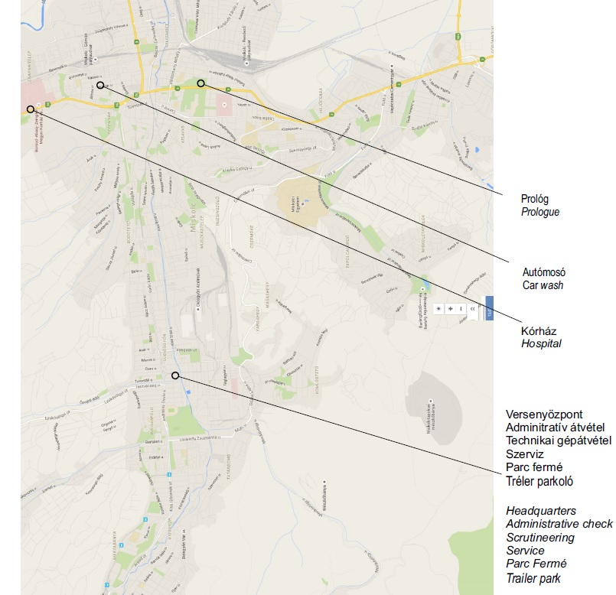
Prologue
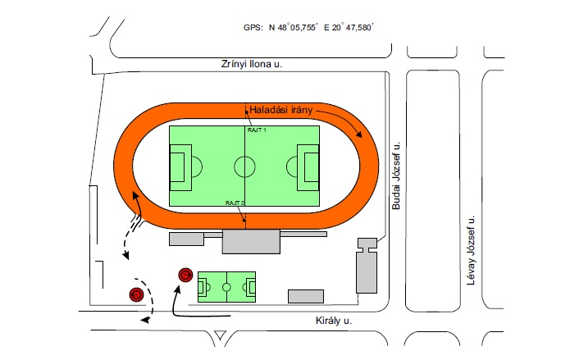

DVTK Stadium

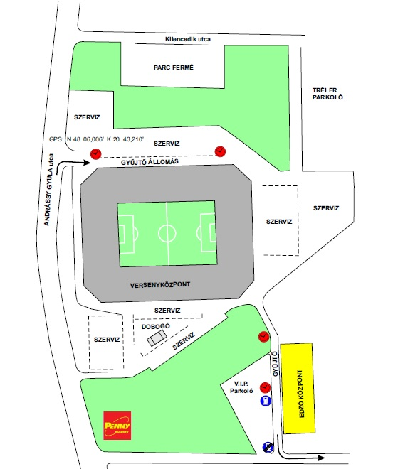

Overview:
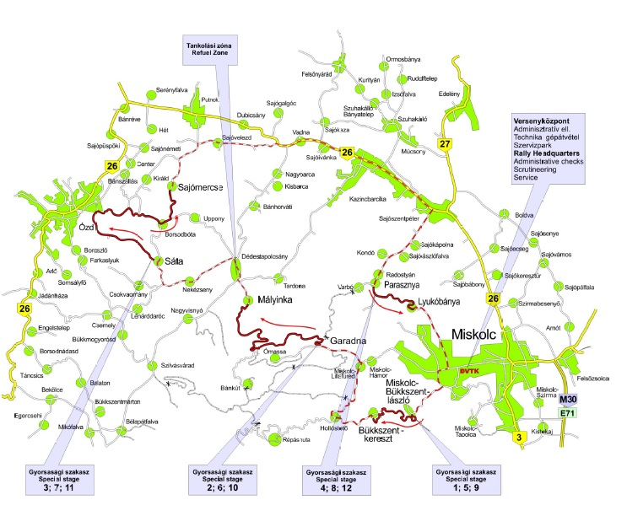

Official Test
